Build Smart on Kubernetes Learning Journey

Introduction to OpenShift Pipelines (Tekton)

Table of Contents

Exercise 4 13

Create Pipeline Tasks 13

Exercise 5 14

Prepare the Pipeline 14

Exercise 6 17

Assemble a Pipeline 17

Exercise 7 20

Trigger a Pipeline 20

Next Steps 24

Next steps 24

## Exercise 4

### Create Pipeline Tasks

**Exercise 4**

**Create Pipeline Tasks**

Tasks consist of a number of steps that are executed sequentially. Tasks are executed/run by creating TaskRuns. A TaskRun will schedule a Pod. Each step is executed in a separate container within the same pod. They can also have inputs and outputs in order to interact with other tasks in the pipeline.

Here is an example of a Maven task for building a Maven-based Java application:

apiVersion: tekton.dev/v1beta1

kind: Task

metadata:

name: maven-build

spec:

resources:

inputs:

- name: workspace-git

targetPath: /

type: git

steps:

- name: build

image: maven:3.6.0-jdk-8-slim

command:

- /usr/bin/mvn

args:

- install

When a task starts running, it starts a pod and runs each step sequentially in a separate container on the same pod. This task happens to have a single step, but tasks can have multiple steps, and, since they run within the same pod, they have access to the same volumes in order to cache files, access configmaps, secrets, etc. You can specify volume using workspace. It is recommended that Tasks uses at most one writeable Workspace. Workspace can be secret, pvc, config or emptyDir.

Note that only the requirement for a git repository is declared on the task and not a specific git repository to be used. That allows tasks to be reusable for multiple pipelines and purposes. You can find more examples of reusable tasks in the [Tekton Catalog](https://github.com/tektoncd/catalog) and [OpenShift Catalog](https://github.com/openshift/pipelines-catalog) repositories.

Install the apply-manifests and update-deployment tasks from the repository using oc or kubectl, which you will need for creating a pipeline in the next section:

|  |
| --- |
| oc create -f <https://raw.githubusercontent.com/openshift/pipelines-tutorial/master/01_pipeline/01_apply_manifest_task.yaml> |
| oc create -f https://raw.githubusercontent.com/openshift/pipelines-tutorial/master/01_pipeline/02_update_deployment_task.yaml |

You can take a look at the tasks you created using the [Tekton CLI](https://github.com/tektoncd/cli/releases):

tkn task ls

resulting in output similar to:

$ tkn task ls

NAME AGE

apply-manifests 10 seconds ago

update-deployment 4 seconds ago

We will be using buildah clusterTasks, which gets installed along with the Pipeline Operator. The Operator installs a few ClusterTask which you can see.

tkn clustertasks ls

resulting in output similar to:

$ tkn clustertasks ls

NAME DESCRIPTION AGE

buildah 1 day ago

buildah-v0-14-3 1 day ago

git-clone 1 day ago

s2i-php 1 day ago

tkn 1 day ago

**End Exercise 4** ___

## Exercise 5

### Prepare the Pipeline

**Exercise 5**

**Prepare the Pipeline**

In the next step, we will define a Pipeline, which will be used to build an application image from an arbitrary GitHub repository and deploy the image as a running instance.

It'll look like this:

apiVersion: tekton.dev/v1beta1

kind: Pipeline

metadata:

name: build-and-deploy

spec:

workspaces:

- name: shared-workspace

params:

- name: deployment-name

type: string

description: name of the deployment to be patched

- name: git-url

type: string

description: url of the git repo for the code of deployment

- name: git-revision

type: string

description: revision to be used from repo of the code for deployment

default: "master"

- name: IMAGE

type: string

description: image to be build from the code

tasks:

- name: fetch-repository

taskRef:

name: git-clone

kind: ClusterTask

workspaces:

- name: output

workspace: shared-workspace

params:

- name: url

value: $(params.git-url)

- name: subdirectory

value: ""

- name: deleteExisting

value: "true"

- name: revision

value: $(params.git-revision)

- name: build-image

taskRef:

name: buildah

kind: ClusterTask

params:

- name: TLSVERIFY

value: "false"

- name: IMAGE

value: $(params.IMAGE)

workspaces:

- name: source

workspace: shared-workspace

runAfter:

- fetch-repository

- name: apply-manifests

taskRef:

name: apply-manifests

workspaces:

- name: source

workspace: shared-workspace

runAfter:

- build-image

- name: update-deployment

taskRef:

name: update-deployment

workspaces:

- name: source

workspace: shared-workspace

params:

- name: deployment

value: $(params.deployment-name)

- name: IMAGE

value: $(params.IMAGE)

runAfter:

- apply-manifests

The various stages of the pipeline need a common storage area to communicate with each other - this is achieved through a Persistent Volume Claim.

You need to create the PersistentVolumeClaim which can be used for Pipeline execution:

|  |
| --- |
| oc create -f https://raw.githubusercontent.com/openshift/pipelines-tutorial/master/01_pipeline/03_persistent_volume_claim.yaml |

Run the following command to check when the volume is available:

oc get pvc

The resulting status should change from:

$ oc get pvc

NAME STATUS VOLUME CAPACITY ACCESS MODES STORAGECLASS AGE

source-pvc Pending

to

$ oc get pvc

NAME STATUS VOLUME CAPACITY ACCESS MODES STORAGECLASS AGE

source-pvc Bound pvc-5a9e5699-fdfb-468c-b0bf-c85b37c39bd0 20Gi RWO ibmc-block-gold 83s

A PipelineRun is how you can start a pipeline and tie it to the persistentVolumeClaim and params that should be used for this specific invocation. The next exercise will use the tkn pipleine start command to link the source-pvc volume to the shared-workspace referenced in the above pipeline task definitions.

**End Exercise 5** ___

## Exercise 6

### Assemble a Pipeline

A pipeline defines a number of tasks that should be executed and how they interact with each other via their inputs and outputs.

In this tutorial, you will create a pipeline that takes the source code of the application from GitHub and then builds and deploys it on OpenShift.

Once you deploy the pipelines, you should be able to visualize pipeline flow in the OpenShift Web Console by switching over to the **Developer** perspective of the OpenShift Web Console. select pipeline tab, select project as pipelines-tutorial and click on pipeline build-and-deploy

This pipeline helps you to build and deploy backend/frontend, by configuring right resources to pipeline.

Pipeline Steps:

1. Clones the source code of the application from a git repository by referring (git-url and git-revision param)
2. Builds the container image of application using the buildah clustertask that uses [Buildah](https://buildah.io/) to build the image
3. The application image is pushed to an image registry by refering (image param)
4. The new application image is deployed on OpenShift using the apply-manifests and update-deployment tasks.

You might have noticed that there are no references to the git repository or the image registry it will be pushed to in pipeline. That's because pipeline in Tekton are designed to be generic and re-usable across environments and stages through the application's lifecycle. Pipelines abstract away the specifics of the git source repository and image to be produced as PipelineResources or Params. When triggering a pipeline, you can provide different git repositories and image registries to be used during pipeline execution. Be patient! You will do that in a little bit in the next section.

The execution order of task is determined by dependencies that are defined between the tasks via inputs and outputs as well as explicit orders that are defined via runAfter.

workspaces field allow you to specify one or more volumes that each Task in the Pipeline requires during execution. You specify one or more Workspaces in the workspaces field.

Create the pipeline by running the following:

|  |
| --- |
| oc create -f https://raw.githubusercontent.com/openshift/pipelines-tutorial/master/01_pipeline/04_pipeline.yaml |

Alternatively, in the OpenShift Web Console, you can click on the **+** at the top right of the screen while you are in the **pipelines-tutorial** project:

Upon creating the pipeline via the web console, you will be taken to a **Pipeline Details** page that gives an overview of the pipeline you created.

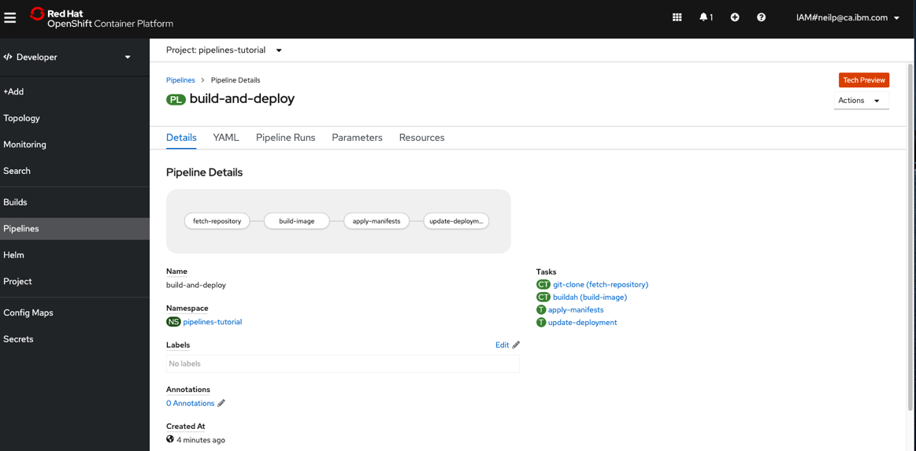

Select the Parameters tab to enter a Parameter to the build-and-deploy pipeline.

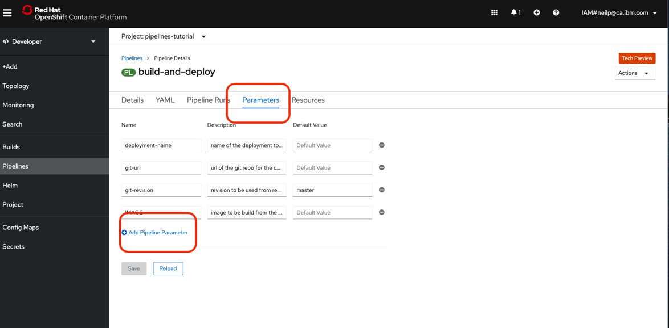

Add the TLSVERIFY parameter and set it to ‘false’. Be sure to click ‘Save’ and then ‘Reload’.

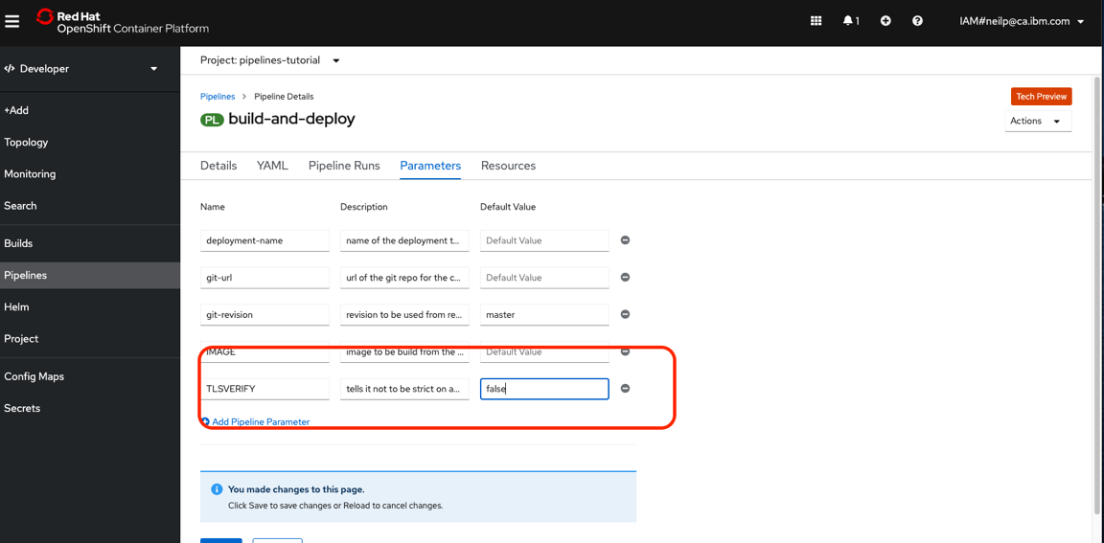

In the cloudshell check the list of pipelines you have created using the CLI:

|  |
| --- |
| tkn pipeline ls |

$ tkn pipeline ls

NAME AGE LAST RUN STARTED DURATION STATUS

build-and-deploy 1 minute ago --- --- --- ---

**End Exercise 6** ___

## Exercise 7

### Trigger a Pipeline

Now that the pipeline is created, you can trigger it to execute the tasks specified in the pipeline.

Lets start a pipeline to build and deploy the backend application using tkn:

|  |
| --- |
| tkn pipeline start build-and-deploy \  -w name=shared-workspace,claimName=source-pvc \  -p deployment-name=vote-api \  -p git-url=https://github.com/IBMDeveloperUK/BSOK-vote-api.git \  -p IMAGE=image-registry.openshift-image-registry.svc:5000/pipelines-tutorial/vote-api |

You should see output like the example below:

$ tkn pipeline start build-and-deploy \

> -w name=shared-workspace,claimName=source-pvc \

> -p deployment-name=vote-api \

> -p git-url=https://github.com/IBMDeveloperUK/BSOK-vote-api.git \

> -p IMAGE=image-registry.openshift-image-registry.svc:5000/pipelines-tutorial/vote-api

Pipelinerun started: build-and-deploy-run-gxv7x

In order to track the pipelinerun progress run:

|  |
| --- |
| tkn pipelinerun logs build-and-deploy-run-gxv7x -f -n pipelines-tutorial |

Similarly, start a pipeline to build and deploy the frontend application:

|  |
| --- |
| tkn pipeline start build-and-deploy \  -w name=shared-workspace,claimName=source-pvc \  -p deployment-name=vote-ui \  -p git-url=http://github.com/IBMDeveloperUK/BSOK-vote-ui.git \  -p IMAGE=image-registry.openshift-image-registry.svc:5000/pipelines-tutorial/vote-ui |

tkn pipeline start build-and-deploy \

-w name=shared-workspace,claimName=source-pvc \

-p deployment-name=vote-ui \

-p git-url=http://github.com/IBMDeveloperUK/BSOK-vote-ui.git \

-p IMAGE=image-registry.openshift-image-registry.svc:5000/pipelines-tutorial/vote-ui

As soon as you start the build-and-deploy pipeline, a pipelinerun will be instantiated and pods will be created to execute the tasks that are defined in the pipeline. See the list of pipelines by running the command below.

tkn pipeline ls

You should see output like the example below:

$ tkn pipeline ls

NAME AGE LAST RUN STARTED DURATION STATUS

build-and-deploy 6 minutes ago build-and-deploy-run-xy7rw 36 seconds ago --- Running

Above, we have started build-and-deploy pipelines, with relevant pipeline parameters to deploy backend/frontend applications using single pipeline

tkn pipelinerun list

You should see output like the example below:

$ tkn pipelinerun list

NAME STARTED DURATION STATUS

build-and-deploy-run-xy7rw 36 seconds ago --- Running

build-and-deploy-run-z2rz8 40 seconds ago --- Running

Check out the logs of the pipelinerun as it runs using the tkn pipeline logs command which interactively allows you to pick the pipelinerun of your interest and inspect the logs:

$ tkn pipeline logs -f

? Select pipelinerun: [Use arrows to move, type to filter]

> build-and-deploy-run-xy7rw started 36 seconds ago

build-and-deploy-run-z2rz8 started 40 seconds ago

After a few minutes, the pipeline should finish successfully.

$ tkn pipelinerun list

NAME STARTED DURATION STATUS

build-and-deploy-run-xy7rw 1 hour ago 2 minutes Succeeded

build-and-deploy-run-z2rz8 1 hour ago 19 minutes Succeeded

Looking back at the project, you should see that the images are successfully built and deployed.

The sample application should look like the image below.

If you want to re-run the pipeline again, you can use the following short-hand command to rerun the last pipelinerun again that uses the same workspaces, params and service account used in the previous pipeline run:

tkn pipeline start build-and-deploy --last

Whenever there is any change to your repository, we need to start a pipeline explicitly to see new changes to take effect

Watch the OpenShift WebConsole Developer perspective and a PipelineRun will be automatically created.

## Next Steps

### Next steps

That completes this lab on using OpenShift Pipelines and Red Hat OpenShift on IBM Cloud. Be sure to take the Quiz and get your Build Smart on Kubernetes Badge.

In this lab you, you learned how to:

* Install the OpenShift Pipelines Operator
* Create Tasks, PipelineResources, and Pipelines
* Trigger a pipeline